August 1, 2019

TO ALL FENCING FEDERATIONS IN ASIA and OCEANIA

Subject: FIE REFEREES EXAM in Bangkok, Thailand

Dear Mr./Ms. Presidents,

We are pleased to announce that an FIE Referees Exam will be held in Bangkok Thailand from October 20 to 24, 2019. This exam will follow the new policy of the FIE in conducting a more thorough examination of referee candidates wanting to have a “B” License. The exam will be conducted by six selected members of the FIE Referees’ Commission. It will be open only to eligible referees with FCA “C” license coming from Asia and Oceania.

The conditions for this exam are as follows:

- The exam will consist of 3 parts (theoretical examination, video analysis and practical examination. Only candidates who passed the theoretical examination and the video analysis test will be allowed to continue with the practical examination. The following schedule are as follows:

20 October 2019 09:00 Theoretical examination SABER
11:00 Video refereeing examination SABER

21 October 2019 09:00 Theoretical examination FOIL
11:00 Video refereeing examination FOIL
14:00 Practical examination SABER

22 October 2019 09:00 Practical examination FOIL

23 October 2019 09:00 Theoretical examination EPEE
11:00 Video referring examination EPEE

24 October 2019 09:00 Practical examination EPEE

- All practical examinations will be held in a special venue using selected good level fencers (not connected with the ongoing Asian Under 23 Fencing Championships)

- Host federation will be entitled to nominate 2 candidates per weapon (total 6 candidates).
If with at least 1 woman candidate per weapon (then maximum of 9 candidates) Reserved slots

- Other federations will be entitled to nominate 1-2 candidates per weapon (maximum of 4 candidates. If with at least 1 woman (then maximum of 5 candidates) First-come, first served.

- A maximum of 30 candidates per weapon will be accepted

- Interested federations may apply by (a) registering their candidates on the FIE Website, and (b) pay the entry fee of Euro 60 to the FIE. Deadline for registration is on September 20, 2019. No application will be accepted if not registered and paid before the deadline. Please inform Ms. NATALIA BODROVA (Natalia.bodrova@fie.ch) of your applications accordingly.

- The examiners in charge of the examinations will prepare the necessary documents and sent to the federations by September 20, 2019. Each candidate must have with him/her these documents, as well as the FIE Rules for competitions in force.

- The results of the examination will be published on the FIE website, after evaluation and approval by the FIE Executive Committee

- Accepted candidates must make their own travel arrangements and hotel bookings in Bangkok. Please coordinate with the Thailand Fencing Federation (for your hotel accommodation, visa and airport transfer.

- The actual venue for the examination and the official hotel for the referee/candidates will be announced soon.

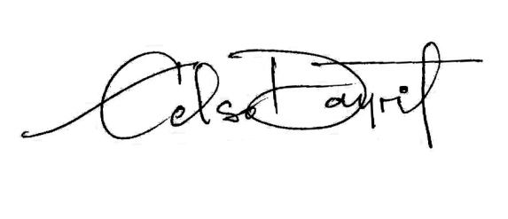
For your information.

CELSO L. DAYRIT
President

